Full Stack Development with MERN
Darshan Ease
- Introduction
• Project Title: Darshan Ease
• Team Members: 1) Chakradhar Reddy Bolla
2)Kalyan Chiravuri
3)Ganesh Balipilli
4)Mullangi Ramesh
5)Shaik Yasmeen
2. Project Overview
Purpose
DarshanEase is a full-stack web application developed to simplify the process of booking darshan slots for temples. The main objective of the project is to eliminate long waiting times, reduce overcrowding, and provide devotees with a convenient online platform to reserve darshan slots from anywhere. The application enables users to view temple information, check available slots, book darshan appointments, and manage their bookings. It also provides an administrative panel for managing temples, slots, users, and bookings efficiently. The project demonstrates the implementation of a complete MERN Stack application with secure authentication, role-based access control, and database management.
Features
The key features of the DarshanEase application include:
- User Registration and Login with secure JWT authentication.
- Role-based access for Admin and Users.
- View a list of temples with images, descriptions, locations, and timings.
- Display available darshan slots for each temple.
- Online darshan slot booking with seat availability management.
- View booking history in the "My Bookings" section.
- Admin Dashboard displaying statistics such as total users, temples, slots, and bookings.
- Temple Management (Add, Edit, Delete temples).
- Slot Management (Add, Edit, Delete slots).
- Booking Management for monitoring all user bookings.
- User Management for viewing registered users.
- Responsive user interface compatible with desktop, tablet, and mobile devices.
- RESTful API developed using Express.js and Node.js.
- MongoDB Atlas cloud database integration.
- Frontend and backend deployment using Render.
3. Architecture
Frontend Architecture (React.js)
The frontend of DarshanEase is developed using React.js, a component-based JavaScript library that enables the creation of interactive and responsive user interfaces. The application is divided into reusable components and pages, making the code modular and easy to maintain. React Router is used for client-side navigation between different pages without refreshing the browser. Axios is used to communicate with the backend REST APIs. Bootstrap is integrated to provide a responsive and user-friendly interface across desktop and mobile devices. JWT tokens are stored in the browser's local storage to maintain user sessions and authenticate API requests.
Frontend Components
- Home Page
- User Registration
- User Login
- Temple Details
- My Bookings
- Admin Dashboard
- Manage Temples
- Manage Slots
- Manage Users
- Manage Bookings
- Add/Edit Temple
- Add/Edit Slot
- Navigation Bar

Backend Architecture (Node.js & Express.js)
The backend of DarshanEase is built using Node.js and Express.js, following the REST API architecture. Express.js handles HTTP requests and routes them to the appropriate controllers. Each module (Authentication, Temple, Slot, Booking, and Admin) has separate route files and controller files to maintain clean code architecture.
JWT (JSON Web Token) is implemented for secure authentication and authorization. Middleware functions are used to verify user authentication and restrict admin-only operations. The backend communicates with MongoDB using Mongoose ODM for efficient data management.
Backend Modules
- Authentication Module
- User Management Module
- Temple Management Module
- Slot Management Module
- Booking Management Module
- Admin Dashboard Module

Database Architecture (MongoDB)
The application uses MongoDB Atlas, a cloud-based NoSQL database, to store and manage application data. MongoDB stores information in collections using JSON-like documents, providing flexibility and high performance.
Mongoose ODM is used to define schemas, validate data, and perform CRUD (Create, Read, Update, Delete) operations.
Database Collections
Users Collection
- User Name
- Email
- Password (Encrypted)
- Role (Admin/User)
Temples Collection
- Temple Name
- Location
- Description
- Temple Timings
- Image URL
Slots Collection
- Temple Reference
- Date
- Time
- Available Seats
Bookings Collection
- User Reference
- Temple Reference
- Slot Reference
- Number of Persons
- Booking Date
- Booking Status
Database Relationships
- One Temple can have multiple Slots.
- One User can create multiple Bookings.
- Each Booking is associated with one Temple and one Slot.
- The Booking collection references User, Temple, and Slot collections using MongoDB ObjectId relationships.
4. Setup Instructions
Prerequisites
Before running the DarshanEase application, ensure that the following software and tools are installed on the system:
Software Requirements
- Node.js (v18 or above) – JavaScript runtime environment.
- npm (Node Package Manager) – Used to install project dependencies.
- MongoDB Atlas – Cloud-based NoSQL database for storing application data.
- Git – Version control system for cloning the project repository.
- Visual Studio Code – Recommended code editor for development.
- Web Browser – Google Chrome or Microsoft Edge for running the application.

Installation
Follow the steps below to set up and run the project on your local machine.
Step 1: Clone the Repository
Clone the project from GitHub using the following command:
git clone https://github.com/your-username/DarshanEase.git
Move into the project directory:
cd DarshanEase

Step 2: Install Backend Dependencies
Navigate to the server folder and install the required packages:
cd server
npm install

Step 3: Install Frontend Dependencies
Open another terminal and navigate to the client folder:
cd client
npm install

Step 4: Configure Environment Variables
Create a .env file inside the server directory and add the following environment variables:
PORT=5000

MONGO_URI=your_mongodb_atlas_connection_string

JWT_SECRET=your_secret_key
Replace your_mongodb_atlas_connection_string with the MongoDB Atlas connection string and your_secret_key with a secure secret key for JWT authentication.

Step 5: Start the Backend Server
From the server directory, run:
npm start
The backend server will start on:
http://localhost:5000

Step 6: Start the Frontend Application
From the client directory, run:
npm start
The React application will start on:
http://localhost:3000

Step 7: Access the Application
Open your web browser and visit:
http://localhost:3000
The DarshanEase homepage will be displayed, allowing users to register, log in, browse temples, book darshan slots, and access the admin dashboard (for authorized administrators).
5. Folder Structure
The DarshanEase project follows a modular folder structure by separating the frontend (React.js) and backend (Node.js & Express.js). This organization improves code readability, maintainability, and scalability.

Client (React Frontend)
The client folder contains the complete React application responsible for displaying the user interface and interacting with the backend APIs.
Folder Structure
client/
│
├── public/
│ ├── index.html
│ └── favicon.ico
│
├── src/
│ ├── components/
│ │ └── Navbar.js
│ │
│ ├── pages/
│ │ ├── Home.js
│ │ ├── Login.js
│ │ ├── Register.js
│ │ ├── TempleDetails.js
│ │ ├── Bookings.js
│ │ ├── AdminDashboard.js
│ │ ├── ManageTemples.js
│ │ ├── AddTemple.js
│ │ ├── EditTemple.js
│ │ ├── ManageSlots.js
│ │ ├── AddSlot.js
│ │ ├── EditSlot.js
│ │ ├── ManageBookings.js
│ │ └── ManageUsers.js
│ │
│ ├── services/
│ │ └── api.js
│ │
│ ├── App.js
│ ├── index.js
│ └── App.css
│
├── package.json
└── node_modules/

Server (Node.js Backend)
The server folder contains the backend application developed using Node.js, Express.js, and MongoDB.
Folder Structure
server/
│
├── controllers/
│ ├── adminController.js
│ ├── authController.js
│ ├── bookingController.js
│ ├── slotController.js
│ ├── templeController.js
│ └── userController.js
│
├── middleware/
│ └── authMiddleware.js
│
├── models/
│ ├── Booking.js
│ ├── Slot.js
│ ├── Temple.js
│ └── User.js
│
├── routes/
│ ├── adminRoutes.js
│ ├── authRoutes.js
│ ├── bookingRoutes.js
│ ├── slotRoutes.js
│ ├── templeRoutes.js
│ └── userRoutes.js
│
├── .env
├── server.js
├── package.json
└── node_modules/

6. Running the Application
The DarshanEase application consists of two independent modules: the React frontend and the Node.js/Express.js backend. Both servers must be started separately for the application to function correctly.

Starting the Backend Server
Open a terminal and navigate to the server directory.
cd server
Install the required dependencies (only the first time):
npm install
Start the backend server:
npm start
Alternatively, if nodemon is configured:
npm run dev
The backend server will start successfully and run on:
http://localhost:5000
The terminal will display:
MongoDB Connected
Server running on port 5000

Starting the Frontend Application
Open another terminal and navigate to the client directory.
cd client
Install the frontend dependencies (only the first time):
npm install
Start the React application:
npm start
The React development server will launch automatically and run on:
http://localhost:3000
7. API Documentation
Summary of API Endpoints
Module | Method | Endpoint
Authentication | POST | /api/auth/register
Authentication | POST | /api/auth/login
Temple | GET | /api/temples
Temple | GET | /api/temples/:id
Temple | POST | /api/temples
Temple | PUT | /api/temples/:id
Temple | DELETE | /api/temples/:id
Slot | GET | /api/slots
Slot | GET | /api/slots/:id
Slot | POST | /api/slots
Slot | PUT | /api/slots/:id
Slot | DELETE | /api/slots/:id
Booking | POST | /api/bookings
Booking | GET | /api/bookings/mybookings
Booking | DELETE | /api/bookings/:id
User | GET | /api/users/profile
User | PUT | /api/users/profile
Admin | GET | /api/admin/dashboard

8. Authentication
The DarshanEase application implements a secure authentication and authorization mechanism using JSON Web Tokens (JWT). The authentication system ensures that only registered users can access protected resources, while administrative operations are restricted to authorized administrators.

User Authentication
The application provides a secure user authentication system that allows users to register and log in using their email address and password.
During registration, the user's password is encrypted using the bcryptjs library before being stored in the MongoDB database. This ensures that passwords are never stored in plain text, improving the overall security of the application.
When a registered user logs in successfully, the server verifies the entered credentials. If the authentication is successful, a JSON Web Token (JWT) is generated and returned to the client.
The generated JWT token contains the user's unique ID and role information and is digitally signed using a secret key stored in the environment variables.

9. User Interface
The DarshanEase application provides a modern, responsive, and user-friendly interface developed using React.js and Bootstrap. The interface is designed to offer a seamless experience for both users and administrators across desktop and mobile devices. Each page is organized with intuitive navigation, attractive layouts, and responsive components to improve usability.
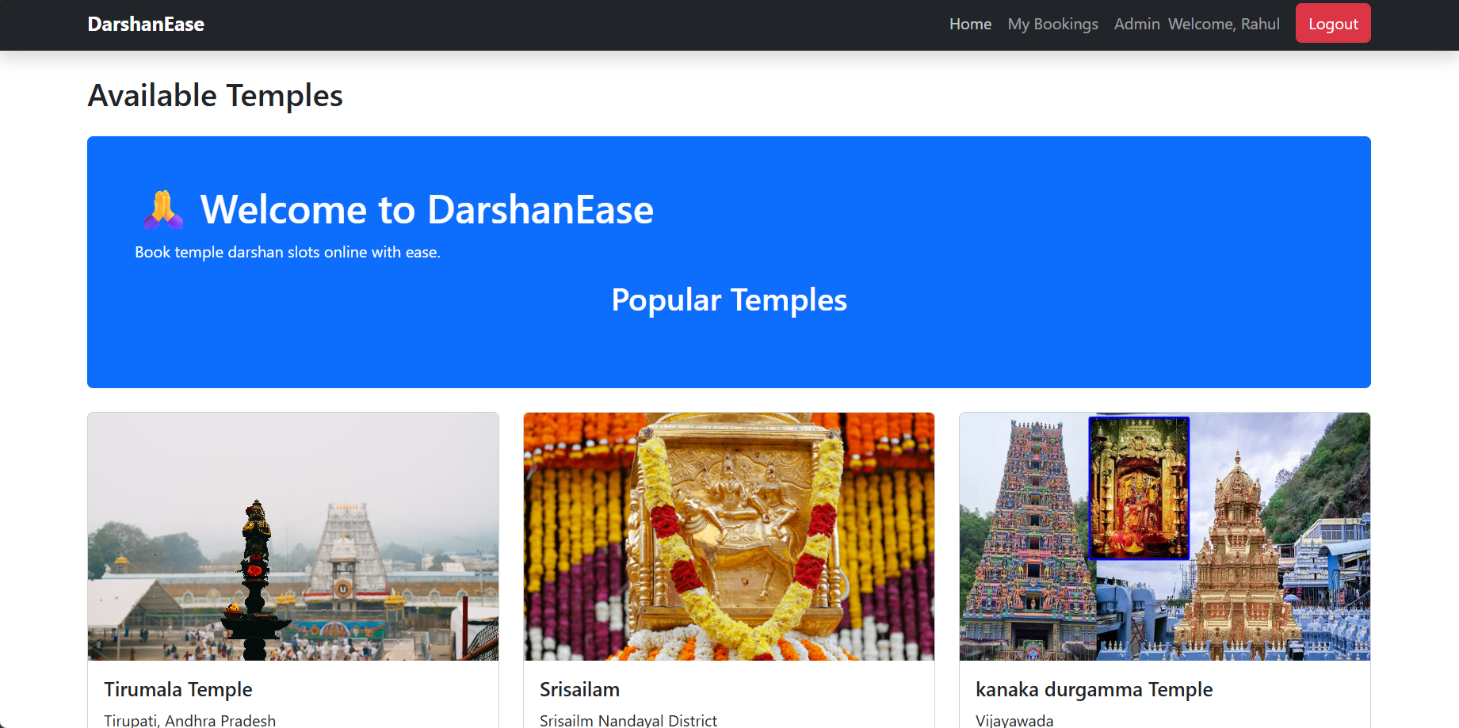
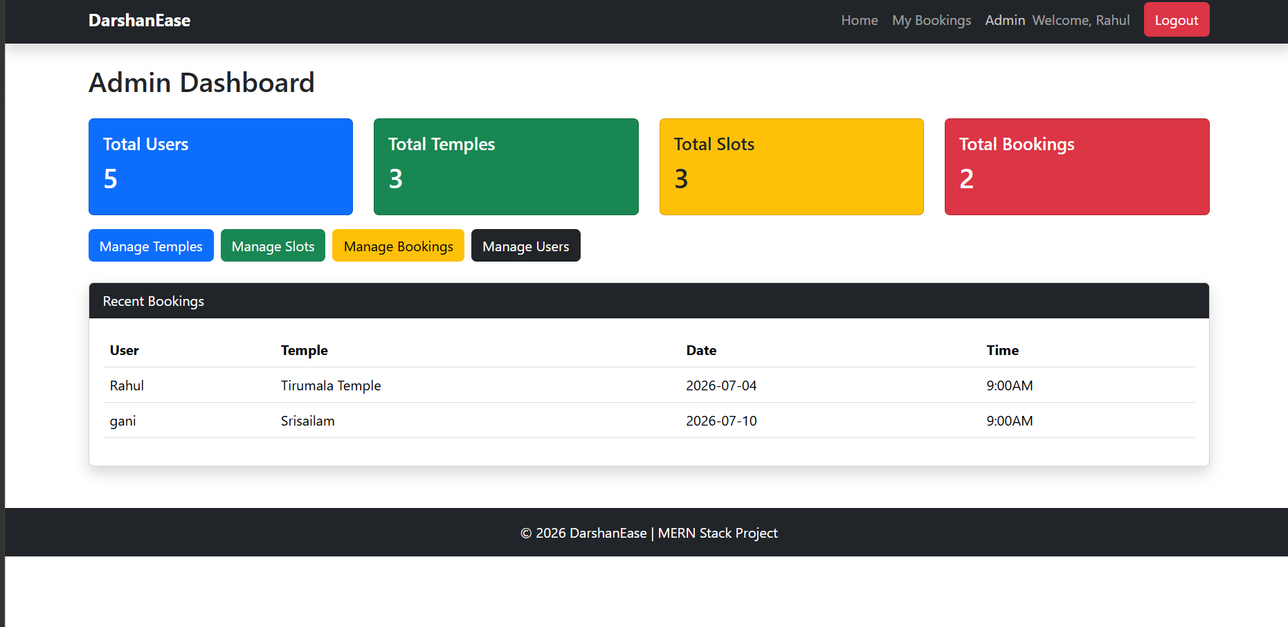
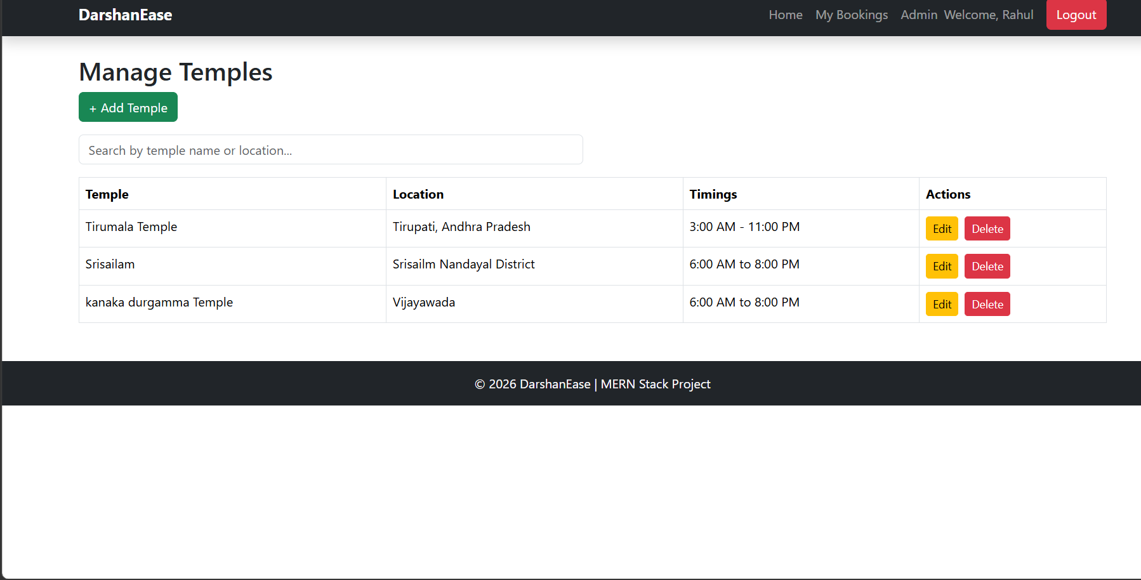
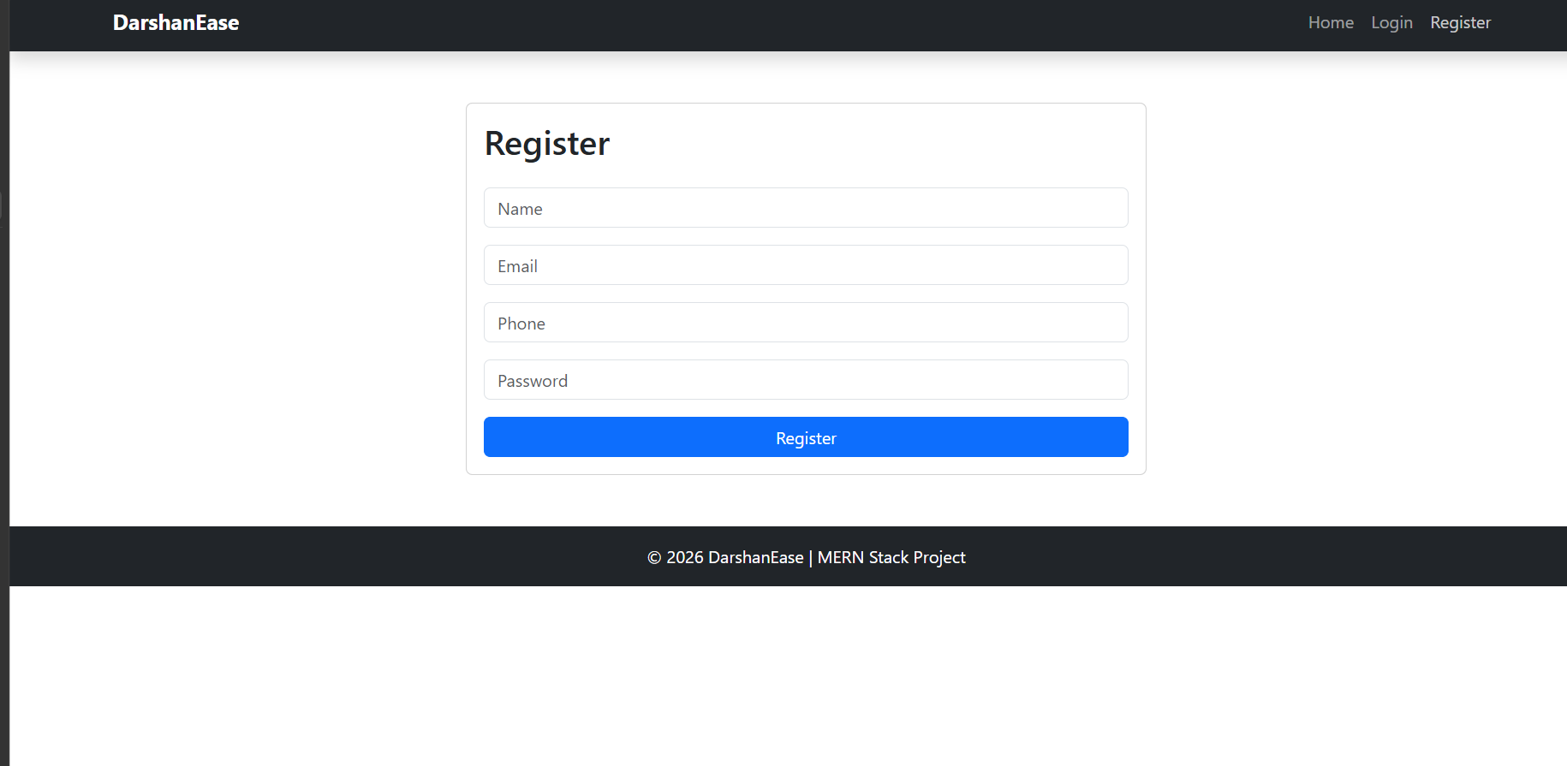
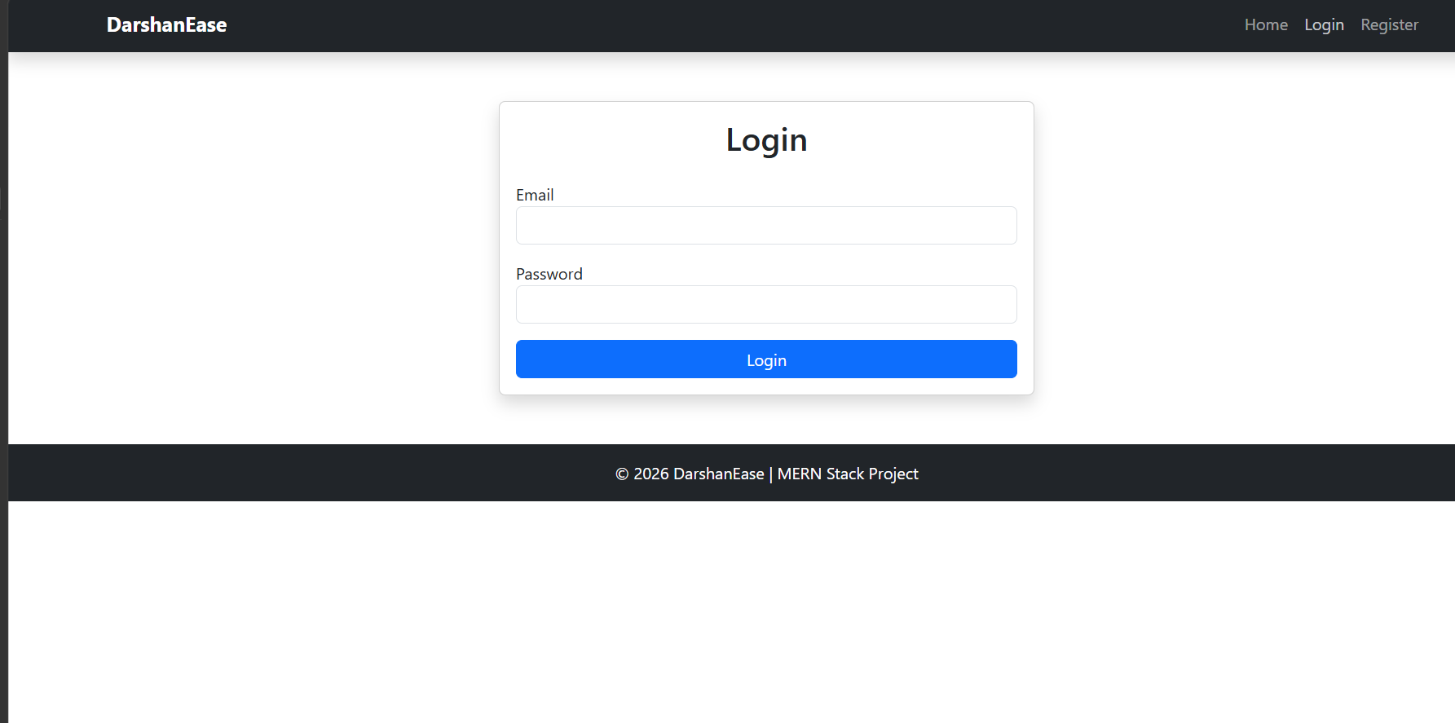
10. Testing
Testing Tools Used
Tool | Purpose
Visual Studio Code | Application development and debugging
Google Chrome | Frontend testing
Postman | REST API testing
MongoDB Compass | Database verification
MongoDB Atlas | Cloud database testing
Render | Deployment testing
Git & GitHub | Version control and source code management

Test Cases
Test Case | Expected Result | Status
User Registration | New user account created successfully | Passed
User Login | User authenticated successfully | Passed
View Temples | Temple list displayed correctly | Passed
View Temple Details | Temple information displayed | Passed
Book Darshan Slot | Booking created successfully | Passed
View My Bookings | User booking history displayed | Passed
Add Temple | Temple added successfully | Passed
Edit Temple | Temple details updated | Passed
Delete Temple | Temple removed successfully | Passed
Add Slot | Slot created successfully | Passed
Edit Slot | Slot updated successfully | Passed
Delete Slot | Slot removed successfully | Passed
View Users | Registered users displayed | Passed
Admin Dashboard | Dashboard statistics displayed correctly | Passed

Testing Outcome
All major functionalities of the DarshanEase application were successfully tested and verified. The application correctly performs user authentication, temple management, slot booking, booking management, and administrative operations. Error handling mechanisms were also tested to ensure the application responds appropriately to invalid inputs and unauthorized access.
The successful completion of these tests demonstrates that the application is stable, reliable, and suitable for deployment in a real-world environment.
11. Screenshots or Demo
https://darshanease-frontend-ulma.onrender.com/

12. Known Issues
Although the DarshanEase application functions correctly and meets its primary objectives, a few limitations and known issues have been identified during development and testing. These issues can be addressed in future versions to further improve the application's usability and performance.
Known Issues
- The application currently does not support an integrated online payment gateway for darshan ticket booking.
- Temple images are currently stored using image URLs or basic uploads; a cloud-based image storage solution such as Cloudinary has not yet been implemented.
- Email or SMS notifications are not sent after successful booking or booking cancellation.
- Users cannot download or print booking tickets in PDF format.

13. Future Enhancements
The DarshanEase application has significant potential for future improvements. Additional features can be incorporated to enhance user convenience, security, and overall system performance.
Future Enhancements
- Integrate an online payment gateway such as Razorpay to enable secure online payments for darshan bookings.
- Implement Cloudinary or AWS S3 for efficient image upload and cloud-based storage of temple images.
- Generate downloadable booking tickets in PDF format with QR codes for easy verification at temples.

Conclusion
- The DarshanEase project successfully demonstrates the development of a secure and scalable full-stack web application using the MERN Stack (MongoDB, Express.js, React.js, and Node.js). It provides an efficient platform for online darshan slot booking, simplifies temple management, and improves the overall user experience. With future enhancements such as online payments, cloud image storage, QR code ticketing, and mobile application support, DarshanEase has the potential to evolve into a comprehensive digital solution for temple management and devotee services.

